**MẪU THIẾT KẾ - CTK 44**

**LAB 5: TÌM HIỂU VÀ CÀI ĐẶT NHÓM MẪU BEHAVIORAL (TIẾP THEO)**

### 1. State

**Ví dụ 1:**

* Context: has current state
* State (interface)
* ConcreteStateA, ConcreteStateB

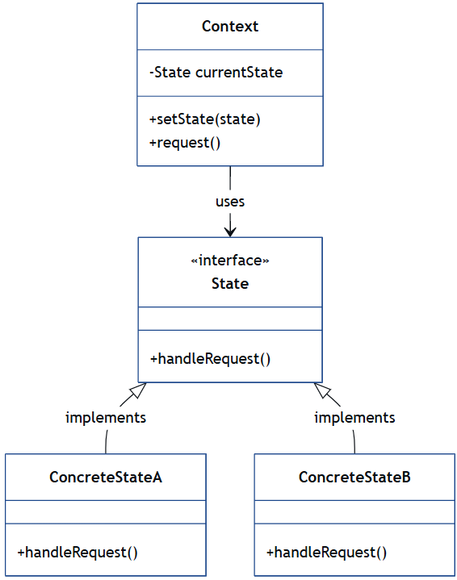

**Ví dụ 2:**

* VendingMachine (Context)
* NoCoinState, HasCoinState, SoldState (ConcreteStates)

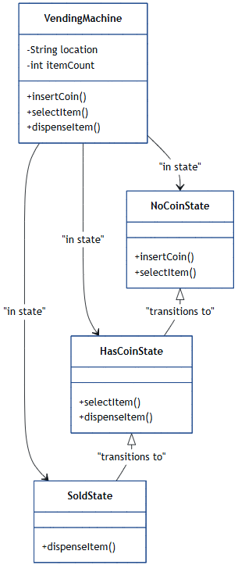

### 2. Strategy

**Ví dụ 1:**

* Strategy (interface)
* ConcreteStrategyA, ConcreteStrategyB
* Context: uses a Strategy

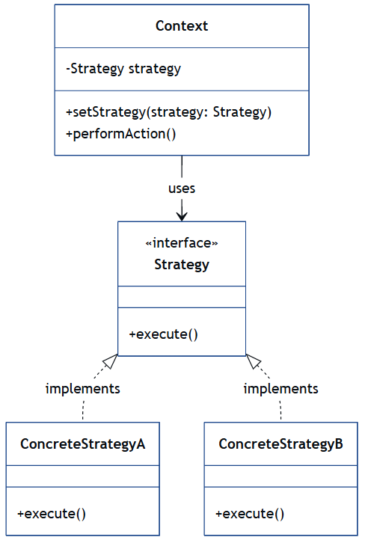

**Ví dụ 2:**

* PaymentStrategy (interface)
* CreditCardPayment, PayPalPayment (ConcreteStrategies)
* ShoppingCart (Context)

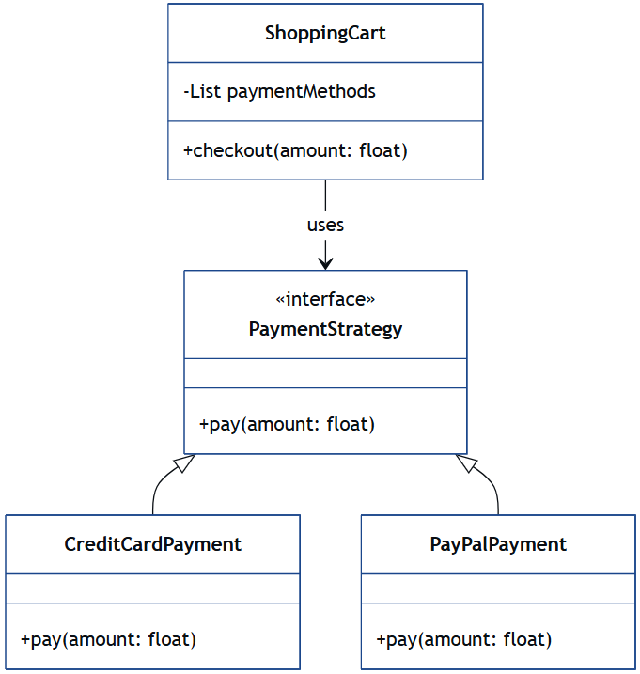

### 3. Template Method

**Ví dụ 1:**

* AbstractClass: defines template method
* ConcreteClass: implements abstract steps

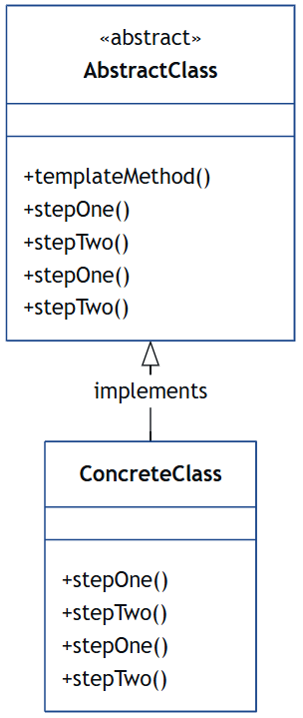

**Ví dụ 2:**

* Game (Abstract)
* Chess, Football (ConcreteClasses)

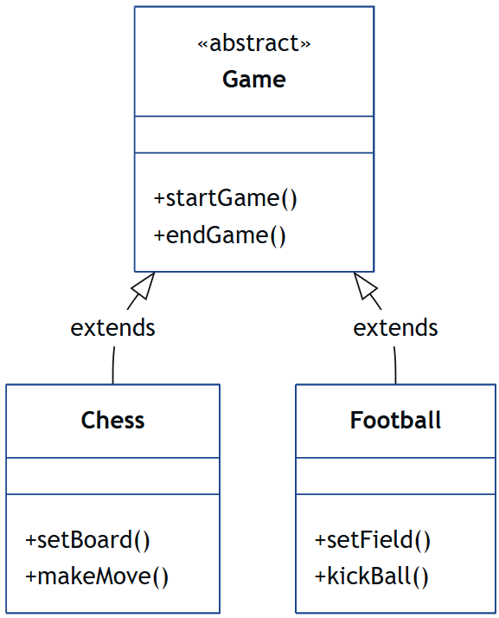

### 4. Visitor

**Ví dụ 1:**

* Visitor: interface with visit()
* ConcreteVisitor1, ConcreteVisitor2
* Element (interface): accept()
* ConcreteElementA, ConcreteElementB

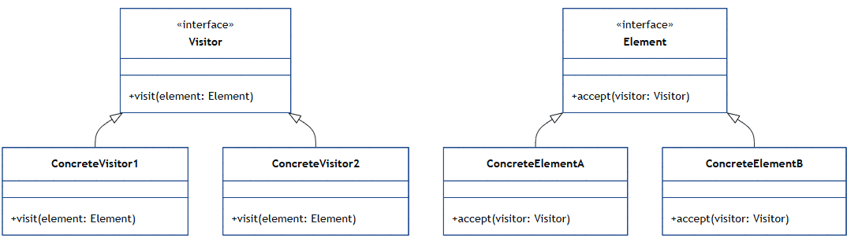

**Ví dụ 2:**

* TaxVisitor, DiscountVisitor (ConcreteVisitors)
* Item, Book, Electronics (ConcreteElements)

